Wellbeing Programme
Starting week beginning 22nd June 2020
All activities are free to participate in but I would ask that you fill in a MDT referral form and return to gemma@countydownrcn.com
Due to social distancing measures, all activities will be accessible remotely through zoom
Please include clients email address.
Monday | Tai Chi  Mike Bean 10:45am logon, class 11am – 12 noon  Tai chi is a slow balanced art form to regulate the mind body and breath. Learn how to relax, strengthen and coordinate the body so you feel energised and stress less all day long.
Tuesday | Health & Wellbeing  Aleida Millar 10:45am logon, class 11am – 12 noon  6 interactive sessions promoting health and wellbeing including aromatherapy, herbs for health, positive sleep patterns and techniques for stress reduction.
Wednesday | Movement to Music  Theresa Messenger 10:45am logon, class 11am – 12 noon  Low Impact Movement and Dance, designed for all levels of mobility and ability to improve your fitness levels, including flexibility, balance, posture and co-ordination, increasing your sense of vitality and wellbeing.
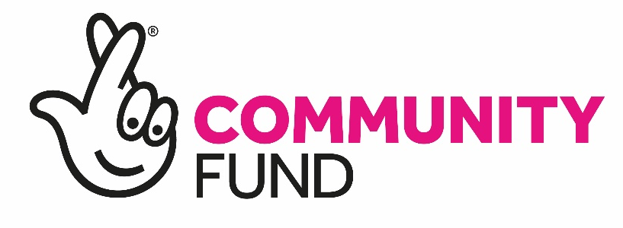

Network Challenge!
JOIN US on
Keep Moving Mondays
2-2.30pm
Walk locally, in your garden or house for 30 mins
Text your name, age and weekly step count to
07389 732749
To get your name on our leaderboard
Spot Prize for the best monthly step count!
For further info please contact jenny@countydownrcn.com
lise@countydownrcn.com
If you haven’t exercised for a long time or if you have any physical conditions that may impact on your ability to exercise, please contact your doctor beforehand.

